

**TIC AND IT'S RELATED TECHS**

**(A COMPEHENSIVE OVERVIEW)°**

**By the students of the 60'thGroup ":**

                                SEHAB HAMZA ABDERRAHMANE

                                SENDID MOHAMED EL HADI

                                TOUBAL ABDELBASSET

                                LOMBARKIA ABDELMOUIZ

                                RAMI ABDELLAH

vero eros et praesent luptatum zzril delenit augue duis dolore et feugiat nulla facilisis.

Lorem ipsum dolor sit amet, consectetuer adipiscing elit, sed diam nonummy nibh euismod tincidunt ut laoreet dolore magna aliquam erat volutpat. Ut wisi enim ad minim veniam, quis nostrud exerci tation ullamcorper suscipit lobortis nisl ut aliquip ex ea commodo consequat. Duis autem vel eum iriure dolor in hendrerit in vulputate velit esse molestie consequat, vel illum dolore eu feugiat nulla facilisis at vero eros et accumsan et iusto odio dignissim qui blandit praesent luptatum zzril delenit augue duis dolore et feugiat nulla facilisis.

Duis autem vel eum iriure dolor in hendrerit in vulputate velit esse molestie consequat, vel illum dolore eu feugiat nulla facilisis at vero eros et accumsan et iusto odio dignissim qui blandit praesent luptatum zzril delenit augue duis dolore et feugiat nulla facilisis.

**The summary of our REPORT :**

|  |  |
| --- | --- |
| CONTENT | PAGE N° |
| ABOUT "TCI" | 3_5 |
| RELATED TECHNOLOGY (GOOGLE AND GOOGLE SERVICES) | 6_7 |
| RELATED TECHNOLOGY (MICROSOFT AND IT’S TOOLS) | 8_10 |
| RELATED TECHNOLOGY (GIT AND GITHUB) | 11_12 |

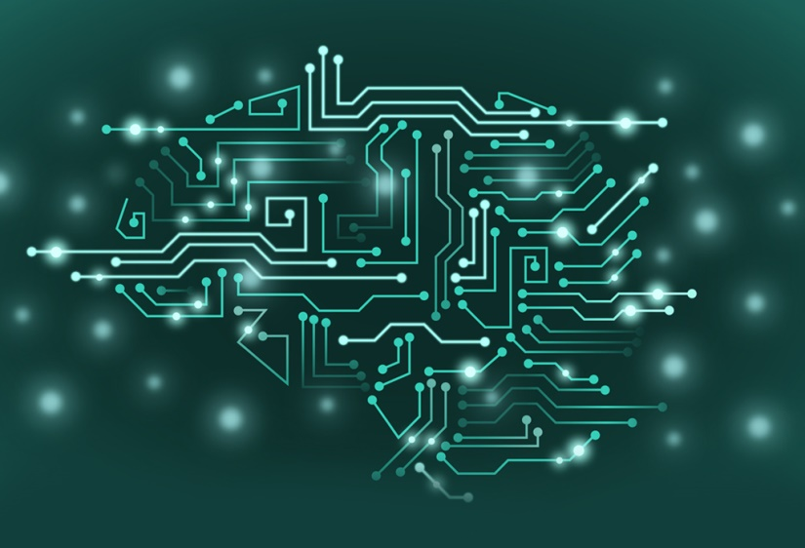



ABOUT "TIC":

**# Information and Communication Technologies (TIC):**

**• A Quick Overview**

• **# 1. Introduction**

Information and Communication Technologies, commonly known as TIC, refer to a broad range of technologies that enable the gathering, processing, storing, and dissemination of information. These technologies play a crucial role in our interconnected digital world.

• **# 2. Definition and Scope**

TIC encompasses a wide array of tools and systems, including computers, software applications, networks, and communication devices. Its scope extends across various sectors, influencing how we work, communicate, and access information.

**• # 3. Evolution and Trends**

TIC has evolved significantly over the years. From the advent of personal computers to the rise of the internet, the field continues to witness rapid advancements. Current trends include the proliferation of cloud computing, artificial intelligence, and the Internet of Things (Iot).

**• # 4. Impact on Various Industries**

TIC has transformed industries such as healthcare, finance, education, and manufacturing. In healthcare, for example, it facilitates telemedicine and digital health records. In finance, online banking and digital transactions have become commonplace.



**" Conclusion ":**

In conclusion, TIC plays a pivotal role in shaping our modern society. Its constant evolution and impact across industries underline the importance of staying informed and adapting to technological changes.

**MORE ABOUT "TIC":**

• # Information and Communication Technologies (ICT): A Quick

• # 1. Introduction

• Information and Communication Technologies (ICT) encompass a diverse set of technologies that enable the management and exchange of information. These technologies play a central role in our modern, connected world.

• # 2. Components of ICT

• # 2.1 Computers

Role: Core processing units for data and information.

Examples: Personal computers, servers.

• # 2.2 Networks

Role: Connect computers and devices for communication.

Examples: Internet, local area networks (LANs).

• # 2.3 Software

Role: Programs and applications that enable tasks and functions.

Examples: Operating systems, applications.



• # 2.4 Communication Devices

Role: Facilitate the exchange of information.

Examples: Smartphones, tablets, routers.

• # 3. Impact on Daily Life ICT has transformed how we live and work: Communication: Instant messaging, video calls, and social media.

Education: E-learning platforms and digital resources.

Business: Efficient operations, online commerce, and virtual collaboration.

• # 4. Current Trends

• # 4.1 Cloud Computing –

•Role: Remote data storage and access

•Impact: Scalability, flexibility, and collaborative tools.

• # 4.2 Artificial Intelligence (AI)

Role: Simulating human intelligence in machines. Impact: Automation, predictive analytics, and smart devices.

• # 5. Challenges As ICT advances, challenges include cybersecurity threats, digital divide issues, and ethical concerns related to emerging technologies.

• # 6. Conclusion ICT is integral to our daily lives, shaping how we connect, work, and access information. Staying informed about current trends and addressing challenges ensures a positive and inclusive digital future.



**LETS TALK MORE ABOUT TCI AND IT'S RELATED TECHS :**

**• GOOGLE SERVICES**

**• # 1. Introduction**

• Google Services form a comprehensive suite of online tools and applications offered by Google, designed to enhance productivity, communication, and access to information.

**• # 2. Key Services**

**• # 2.1 Gmail**

•Purpose: Email communication and collaboration

•Features: Robust email management, integrated chat, and file sharing.

**• # 2.2 Google Drive**

•Purpose: Cloud-based storage and collaboration

•Features: Document creation, file storage, and real-time collaboration.

**• # 2.3 Google Docs, Sheets, and Slides**

• Purpose: Document, spreadsheet, and presentation creation

• Features: Online collaboration, real-time editing, and easy sharing.

**• # 2.4 Google Calendar**

•Purpose: Time management and scheduling

•Features: Event scheduling, reminders, and shared calendars.



**• # 3. Integration Capabilities**

Google Services seamlessly integrate with each other, fostering a cohesive digital environment. Files created in Google Docs, for instance, can be stored and shared through Google Drive, and linked in Gmail for efficient communication.

**• # 4. Accessibility**

Google Services are accessible from various devices with internet connectivity, promoting flexibility and collaboration regardless of location.

**• # 5. Conclusion**

Google Services simplify tasks, promote collaboration, and enhance efficiency in personal and professional settings. Their user-friendly interfaces and interoperability make them valuable tools for a wide range of users.





**MICROSOFT TOOLS**

**•Microsoft Tools: Empowering Productivity and Collaboration**

**• # 1. Introduction**

Microsoft Tools, developed by Microsoft Corporation, form a robust suite of software applications that have become integral to personal and professional productivity. These tools are designed to enhance efficiency, facilitate collaboration, and provide a seamless digital experience.

**• # 2. Key Microsoft Tools**

**• # 2.1 Microsoft Office Suite**

Microsoft Office is a cornerstone of productivity tools, offering a suite of applications tailored for various tasks:

Microsoft Word: Document creation with advanced formatting options.

Microsoft Excel: Powerful spreadsheet analysis and data visualization.

Microsoft PowerPoint: Dynamic presentation development with multimedia capabilities. These applications are widely used across industries for their user-friendly interfaces and comprehensive functionalities.

**• # 2.2 Microsoft Teams**

• Microsoft Teams is a collaborative platform designed for virtual communication and teamwork: - **Video Conferencing:** Conduct virtual meetings with high-quality video and audio.

• Chat: Real-time messaging for quick communication.



**• File Sharing**: Seamless sharing and collaboration on documents within the platform. Teams serve as a central hub for communication and project management, integrating with other Microsoft 365 apps for a unified experience.

**• # 2.3 OneDrive**

OneDrive is Microsoft's cloud storage service that allows users to store, access, and share files securely:

**Cloud-Based Storage**: Access files from any device with an internet connection. Real-time Collaboration: Multiple users can collaborate on documents simultaneously.

**Version History**: Track changes and revert to previous versions if needed. OneDrive enhances mobility and collaboration, providing a centralized repository for files.

**• # 2.4 Azure**

Microsoft Azure is a comprehensive cloud computing platform offering a range of services:

**Hosting Applications**: Deploy and manage web applications.

**Database Management**: Store and manage data with scalable databases.

**Scalable Computing Power**: Access computing resources on-demand. Azure empowers businesses with scalable and flexible solutions, supporting digital transformation initiatives.

**• #3. Integration and Compatibility**

• One of the key strengths of Microsoft Tools lies in their seamless integration, fostering a unified user experience: - **Cross Application Integration:** Documents created in Office Suite seamlessly integrate with OneDrive.

**Teams Integration**: Files stored in OneDrive can be easily shared and collaborated on within Teams.

**Single Sign-On**: Unified login credentials across the Microsoft 365 ecosystem. This integration streamlines workflows, allowing users to transition between applications effortlessly.

**• # 4. Accessibility and Flexibility**

Microsoft Tools prioritize accessibility across various devices and platforms:



**Cross-Device Compatibility**: Access documents and collaborate on the go, from desktops to smartphones.

**Web-Based Applications**: Use online versions of Office apps without installing software.

**Mobile Apps**: Access key functionalities through mobile applications. This flexibility ensures that users can work anytime, anywhere, and on the device of their choice.

**• # 5. Impact on Business**

Microsoft Tools have significantly impacted business operations, offering solutions that enhance collaboration, streamline workflows, and improve data management: **Remote Collaboration**: Teams facilitates virtual collaboration, supporting remote work.

**Data Security**: OneDrive provides secure cloud storage with robust data protection measures.

**Scalability**: Azure enables businesses to scale computing resources based on demand. The widespread adoption of Microsoft Tools has become a hallmark of modern and efficient business practices.

**• # 6. Conclusion**

In conclusion, Microsoft Tools stand as a comprehensive suite that empowers individuals and organizations to achieve more. From the foundational Office Suite to the collaborative power of Teams, and the scalable solutions offered by Azure, these tools are instrumental in shaping a digital landscape where productivity and collaboration thrive.



**AND**

**GITHUB??**

**# Git and GitHub:Streamlining Collaboration in Software Development**

**# 1. Introduction**

**Git and GitHub are powerful tools that revolutionize the way software development projects are managed, tracked, and collaborated upon. Git, a distributed version control system, provides a robust framework for tracking changes in source code, while GitHub, a webbased platform, facilitates collaborative development and project management.**

**# 2. Git: Une image contenant Panneau de signalisation, signe

Description générée automatiquement**

**Version Control at its Core**

**# 2.1 Purpose**

**Git is designed to track changes in source code during software development, enabling collaboration among multiple contributors.**

**# 2.2 Key Features**

**Branching: Create parallel branches for feature development or bug fixes. Merging: Integrate changes from one branch into another. Version History: Detailed history of commits, allowing easy rollback.**

**• # 2.3 Benefits**

**Git ensures a streamlined and efficient development process by providing a structured way to manage code changes, reducing conflicts, and enabling collaboration among developers.**

**• # 3. GitHub: A Collaborative Development Platform**



**• # 3.1 Purpose**

**GitHub extends Git's capabilities by providing a collaborative online platform for developers to host, review, and manage code repositories.**

**• # 3.2 Key Features**

**Repository Hosting: Store and manage Git repositories online.**

**Pull Requests: Propose changes and manage code review processes.**

**Issue Tracking: Track bugs, enhancements, and tasks.**

**• # 3.3 Benefits**

**GitHub facilitates a collaborative and transparent development workflow, allowing teams to work seamlessly, track issues, and contribute to projects regardless of geographical location.**

**• # 4. Integration and Collaboration**

**• # 4.1 Team Collaboration**

**GitHub promotes team collaboration by providing a centralized platform where developers can contribute to projects, discuss changes, and manage tasks.**

**• # 4.2 Integration with CI/CD Integration with Continuous Integration/Continuous Deployment (CI/CD) pipelines ensures automated testing and deployment processes, improving code quality.**

**• # 5. Impact on Open Source Development**

**• GitHub has become a cornerstone for open-source projects, fostering a global community of developers who can contribute to and benefit from a vast array of projects.**

**• # 6. Conclusion**

**In conclusion, Git and GitHub together form a dynamic duo that has transformed the landscape of software development. Git's version control capabilities provide a structured approach to managing code changes, while GitHub's collaborative platform facilitates efficient teamwork, making them indispensable tools for modern development projects.**



**UNFORTUNATLY WE ARRIVE TO THE END OF OUR OVERVIEW AND OUR REPORT BUT THEESE PREVIOUS TECHNOLOGIES AREN'T THE ONLY RELATED ONES TO "TIC" THERFORE THERE EXISTS MUCH MORE RELATED TECHS TO THIS PREVIOUS WE MENTION SOME OF THEM IN THE FOLLOWING TABLE.**

|  |
| --- |
| **OTHER RELATED TECHNOLOGIES TO "TIC"** |
| **CLOUD COMPUTING** |
| **A.I ( ARTIIFICIAL INTELLIGENCE ) AND MACHINE LEARNING** |
| **INTERNET OF THINGS** |
| **BIG  DATA** |
| **CUBER SECURITY** |
| **VIRTUALISATION** |
| **MOBILE TECHNOLOGIES** |
| **ROBOTICS** |
| **BLOCK CHAINE** |
| **5G TECHNOLOGY** |



**THE END**